Madras Institute of Technology, Anna University

Department of Computer Technology

Project Review I for Phase II

Batch: 8/8 CSE ‘S’

**Project Title**: Crop Recommendation System using Machine Learning Techniques.

**Domain**: Machine Learning, Image Processing.

**Project Members**:

1. S. Krishna Prasad **2.** B. Sivasreedharan **3.** S. Jaishanth

**Guide:** Dr. P. Varalakshmi

**Introduction:**

This document proposes a crop recommendation system using Deep Learning: Convolutional Neural Network (CNN) and Support Vector Machine (SVM). The CNN takes in the image of the soil as the input and produces the soil class (type) as the output. The soil class together with geographic parameters like latitude and longitude is fed into SVM which produces the suitable crop as the output. Convolutional Neural Network is a type of feed-forward artificial neural network in which the connectivity pattern between its neurons is inspired by the organization of the animal visual cortex. In simple words, it replicates the working of a human retina. Support Vector Machine is a typical classifier model. We are using SVM which predicts the best fit for the input with the help of Radial Basis Function (RBF) as the kernel. Further scope of the project would extend to predictive analytics on the commodity market of the goods grown in the agricultural fields to predict its waxing and waning. The remote sensing data can provide information of crop environment, crop distribution, and leaf area index (LAI), and crop phenology. This information is integrated in crop simulation models, in a number of ways such as use as direct forcing variable, use for recalibrating specific parameters, or use simulation-observation differences in a variable to correct yield prediction.

**Overall project objective:**

* Collect satellite images for agricultural crop monitoring.
* Classify the image based on Soil type, moisture content, weather conditions, pH value, organic nitrogen etc.
* Perform satellite image processing with respect to textural and spatial features.
* Analyse crop patterns with the help of past records and map them with calculated data.
* Monitor crop yield and find ways for increasing it.
* Recommend profitable crops for each land type.

**Architecture:**

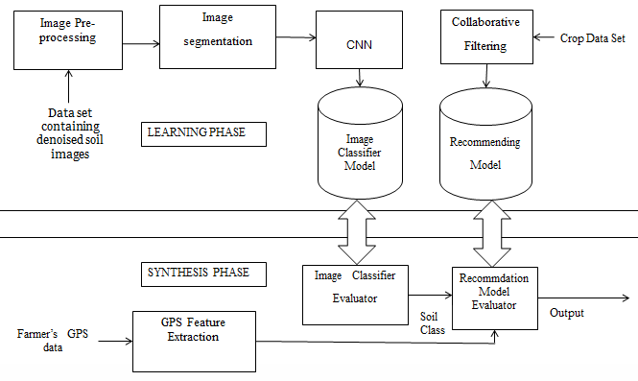

**Flow Diagram:**

**C:\Users\dell\Downloads\Final Year Review 1.png**

**Implementation Screenshots:**

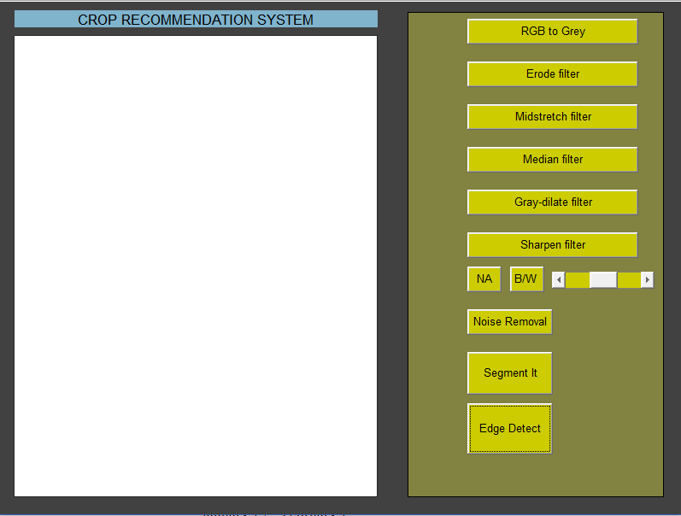

**User Interface**

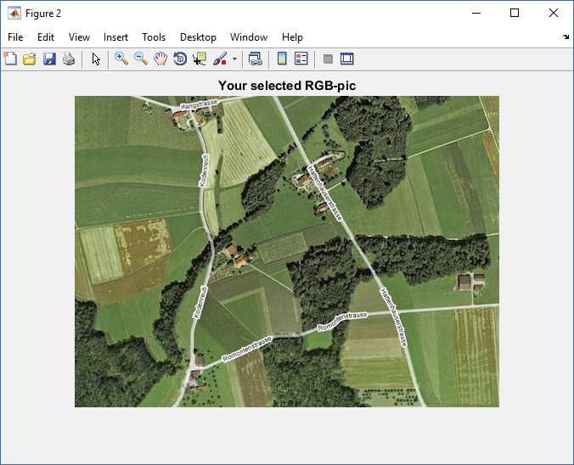

**Image Data**

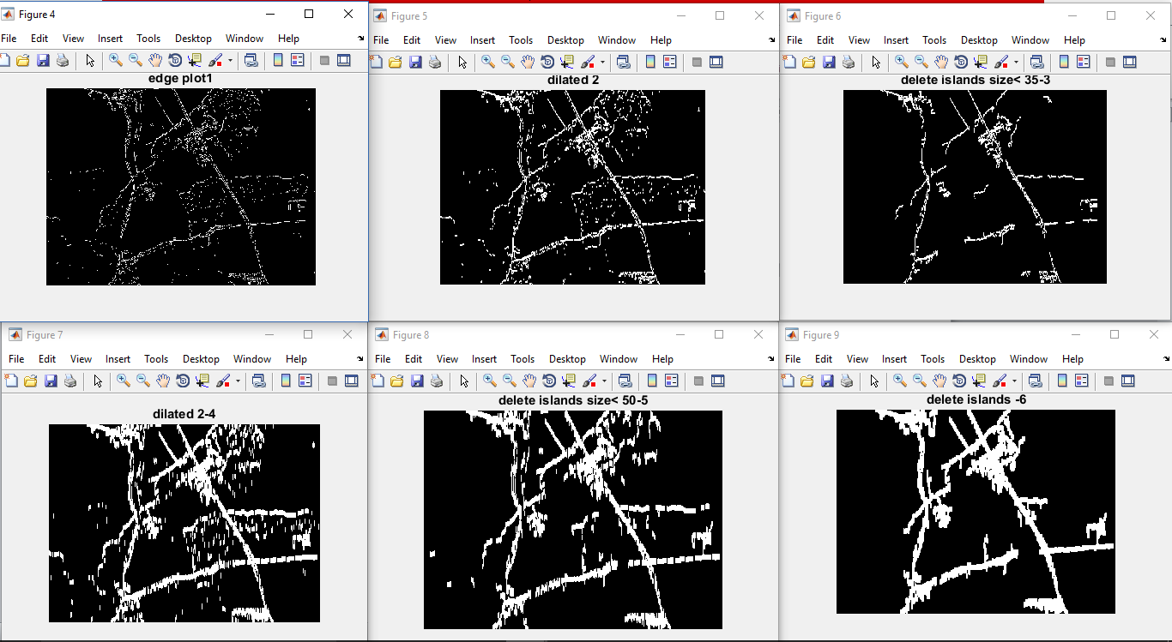

**Edge Detect**

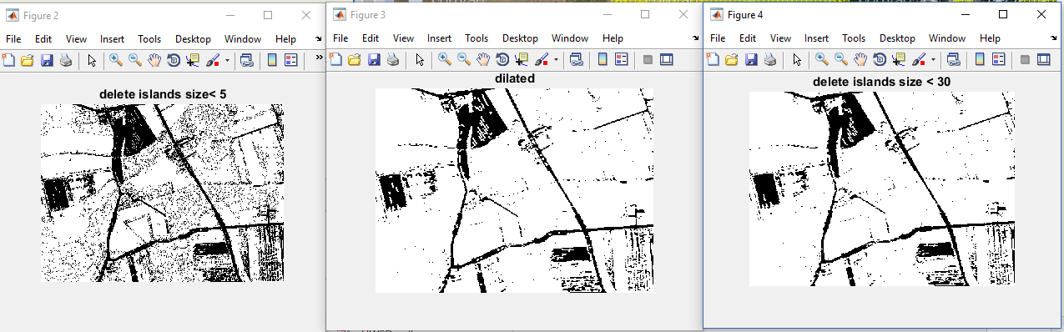

**Noise Removal**

**Data set description:**

[**http://www.fao.org/soils-portal/soil-survey/soil-maps-and-databases/harmonized-world-soil-database-v12/en/**](http://www.fao.org/soils-portal/soil-survey/soil-maps-and-databases/harmonized-world-soil-database-v12/en/)

|  |  |  |
| --- | --- | --- |
| Soil Qualities | | Soil Characteristics |
| SQ1 | Nutrient availability | Soil texture, soil organic carbon, soil pH, total exchangeable bases |
| SQ2 | Nutrient retention capacity | Soil Organic carbon, Soil texture, base saturation, cation exchange capacity of soil and of clay fraction |
| SQ3 | Rooting conditions | Soil textures, bulk density, coarse fragments, vertic soil properties and soil phases affecting root penetration and soil depth and soil volume |
| SQ4 | Oxygen availability to roots | Soil drainage and soil phases affecting soil drainage |
| SQ5 | Excess salts. | Soil salinity, soil sodicity and soil phases influencing salt conditions |
| SQ6 | Toxicity | Calcium carbonate and gypsum |
| SQ7 | Workability (constraining field management) | Soil texture, effective soil depth/volume, and soil phases constraining soil management (soil depth, rock outcrop, stoniness, gravel/concretions and hardpans) |

1. Test.csv - Soil and Ground properties.

2. Training_set.csv – Image parameters training facilitation.

Algorithms:

**Collaborative Filtering:**

* List the  users {u1,u2,u3,….un} and a list of n items {i1,i2,i3,….in}.
* Each user has a list of items , user has to rate it.
* *Vi , j* = vote of user *i* on item *j.*
* *Ii  =* items for which user *i* has voted.
* Calculate the mean value for a user using



* For each user *a* in the test set:
* Split *a* votes into observed *(I)* and to-predict *(P)*
* Measure average absolute **deviation** between predicted and actual votes in *P*
* Predict votes in *P*, and form a **ranked list**
* Assume
  + Utility of *k*-th item in list is *max(va,j-d,0)*, where *d* is a “default vote”
  + Probability of reaching rank *k* drops exponentially in *k.* Score a list by its expected utility *Ra*
* Average *Ra* over all test users

**Segmentation via clustering- hole filling algorithm**

1. Transforming the input image into feature representation. Read the original image data to obtain the representation in three colour channels.
2. Identifying the cluster centres and number.
3. Computing the density ρ and distance δ by using the equation (1) and (3) respectively. And then composing the decision graph based on the density and distance
4. Choosing the data points with high density (ρ) and large distance (δ) as the cluster centres. And then, we can obviously ﬁgure out the cluster number.
5. Assigning the remaining points to the clusters. • Marking point xi with the same label of point xj if satisfying the follow two conditions: (1) ρj >ρi and (2) dij = min l
6. Achieving the ﬁnal segmentation based on the labels marked through last step.

**Timeline Chart:**

* December 15 – January 1

Image segmentation based on crop behavioural parameters.

* January 1 – January 15

Evaluating segmentation results to be given as input to machine learning phase.

* January 15 – February 1

Deep neural network would function in the pre-processed training images as input and tries to replicate the human-retinal functionality, building a Image Classifier Model.

* February 1 – February 15

The SVM module would take in the training soil class, longitude and latitude as the input and uses Radial Basis Function (RBF) as kernel, to find the best-fit curve for the given input data and produces Recommendation Model as output.

* February 15 – March 1

This module takes in the pre-processed input image as the and uses the pickled Image Classifier Model to predict the soil class.

* March 1 – March 15

This module takes in the soil class and GPS parameters as input and also uses the Recommendation Model to recommend the crop suitable for the land.

Enhancement to collaborative deep recommendation system used.